**A**

**Project Report**

on

# Manobal : A Personality Development App

submitted as partial fulfilment for the award of

**BACHELOR OF TECHNOLOGY**

**DEGREE**

**SESSION 2024-25**  in

# Computer Science and Engineering

By

Prince Kumar (2102310100075)

Nitish Kumar (2102310100070)

Khushi Chaudhary (2102310100055)

Prabhat Chaudhary (2102310100073)

**Under the guidance of**

Mr. Hemant Kumar Bhardwaj



**R D Engineering College, Ghaziabad**

Affiliated to



**Dr. A.P.J. Abdul Kalam Technical University, Lucknow**

**(Formerly UPTU)**  **MAY, 2025**

# DECLARATION

*We hereby declare that this submission is our own work and that, to the best of our knowledge and belief, it contains no material previously published or written by another person nor material which to a substantial extent has been accepted for the award of any other degree or diploma of the university or other institute of higher learning, except where due acknowledgment has been made in the text.*

*Signature*

*Name : Prince Kumar*

*Roll No. : 2102310100075*

*Date :*

*Signature*

*Name : Nitish Kumar*

*Roll No. : 2102310100070 Date :*

*Signature*

*Name : Khushi Chaudhary*

*Roll No. : 2102310100055*

*Date :*

*Signature :*

*Name : Prabhat Chaudhary Roll No. : 2102310100073*

*Date :*

# CERTIFICATE

This is to certify that *Project Report entitled –* ***“Manobal”*** which is submitted by ***Prince Kumar*****(2102310100075), Khushi Chaudhary (2102310100055), Nitish Kumar (2102310100070), Prabhat Chaudhary (2102310100073)** in partial fulfillment of the requirement for the award of degree B. Tech. in Department of CSE & CSE Allied, of Dr.

A.P.J. Abdul Kalam Technical University, U.P., Lucknow., is a record of the candidate own work carried out by him/her under my/our supervision. The matter embodied in this Project report is original and has not been submitted for the award of any other degree.

|  |  |
| --- | --- |
| **Mr Hemant Kumar Bhardwaj** | **Prof. Lav Kumar Dixit** |
| **(Assistant Prof.)** | **(Head, CSE & CSE Allied)** |

**Date:**

# ACKNOWLEDGEMENT

*It gives us a great sense of pleasure to present the report of the B. Tech Project undertaken during B.Tech Final Year. We owe special debt of gratitude to our guide*

***Mr. Hemant Kumar Bhardwaj****, Department of CSE, R.D. Engineering College, Ghaziabad for his constant support and guidance throughout the course of our work. His sincerity, thoroughness and perseverance have been a constant source of inspiration for us. It is only his cognizant efforts that our endeavours have seen light of the day.*

*We express our sincere gratitude to* ***Prof. Lav Kumar Dixit****, HoD, Department of CSE & CSE Allied, R.D. Engineering College, Ghaziabad, for his stimulating guidance, continuous encouragement and supervision during the development of the project.*

*We are extremely thankful to* ***Prof. Mohd. Vakil****, Dean Academics, R.D. Engineering College, Ghaziabad, for his full support and assistance during the development of the project.*

*We also do not like to miss the opportunity to acknowledge the contribution of all faculty members of the department for their kind assistance and cooperation during the development of our project. Last but not the least, we acknowledge our friends for their contribution in the completion of the project.*

|  |  |
| --- | --- |
| *Signature :*  *Name : Prince Kumar* | *Signature :*  *Name : Nitish Kumar* |
| *Roll No. : 2102310100075* | *Roll No. : 2102310100070* |
| *Date :* | *Date :* |
| *Signature :*  *Name : Khushi Chaudhary* | *Signature :*  *Name : Prabhat Chaudhary* |
| *Roll No. : 2102310100055* | *Roll No. : 2102310100073* |
| *Date :* | *Date :* |

# ABSTRACT

In today's fast-paced digital world, personality development is increasingly recognized as a critical component for personal and professional success. Traditional methods for enhancing soft skills often lack personalization, engagement, and practical applicability.

To address these challenges, we have developed Manobal, a mobile application designed to assess and enhance user personalities using the scientifically validated OCEAN model, also known as the Big Five Personality Traits.

The OCEAN model evaluates users across five key dimensions: Openness, Conscientiousness, Extraversion, Agreeableness, and Neuroticism. Based on an initial dynamic assessment, Manobal generates customized learning tasks tailored to the user's dominant personality traits. The system also includes community interaction features to promote peer learning and user engagement.

Built using React Native for cross-platform development and Node.js with MongoDB for backend services, Manobal integrates secure authentication via JWT and uses structured logic to assign tasks without relying on complex AI models. Ethical considerations like data privacy, transparency, and user consent are prioritized in the app’s design.

This report details the conceptual foundation, existing systems, methodology, implementation, results, and future directions of Manobal. The app not only provides actionable insights for users but also serves as a deployable solution for institutions

seeking structured personality development tools

# LIST OF CONTENTS

**DECLARATION**   **I**

**CERTIFICATE**  **II**

**ACKNOWLEDGE III**

**ABSTRACT LIST**  **IV**

**LIST OF FIGURES V**

**LIST OF TABLES VI**

**LIST OF ABBREVIATIONS VII**

**CHAPTER 1 INTRODUCTION ....................................................................................1**

1.1 Introduction to soft skillsand their importance.................................................. 1

1.2 Role of AI in Skill Development........................................................................ 1

1.3 Rise of Personalised Apps ...................................................................... 2

1.4 Introduction to OCEAN Model.................................................................. 3 1.5 Problem Statement: Lack of adaptive, engaging, and.............................. 5 peer-interactive platforms

1.6 Objective of the “Manobal” App................................................................6

**CHAPTER 2 LITERATURE REVIEW ..........................................................................7**

2.1 Review of existing app s like “Bestify Me” and “Make me Better” ........... 7

2.2 Limitations of traditional learning systems ..............................................10 2.3 Detailed analysis of OCEAN-based tools ...............................................11

**CHAPTER 3 PROPOSED METHODOLOGY ..............................................................14**

3.1 Module-wise structure .............................................................................14

3.1.1 Authentication Module ............................................................ ..14

3.1.2 Assessment Module (Dynamic OCEAN) ...................................15

3.1.3 Task Generation Module ............................................................15

3.1.4 Dashboard and Feedback........................................................... 17 3.1.5 Community Interaction ............................................................... 18

3.2.1 ER Diagram .................................................................................19

3.2.2 DFD (Level 0&1) ..........................................................................23

3.2.3 Use Case Diagram ....................................................................24

3.2.4 Activity Diagram .........................................................................25

3.2.5 Flowcharts ..................................................................................26

3.3 Tools and Tech Used.................................................................................28

3.4 Dataset Description ..................................................................................29

3.5 Security Considerations............................................................................30

3.3 Feasibility Study (Technical, Operational, Economic) ..............................31

**CHAPTER 4 IMPLEMENTATION AND RESULTS..............................................33**

4.1 Screenshots of: ...........................................................................................33

4.1.1 Login/Register ...............................................................................33

4.1.2 Assessment Interface ....................................................................34

4.1.3 Dashboard .....................................................................................34

4.1.4 Task Assignment ............................................................................35

4.1.5 Community Posts............................................................................35

4.1.6 Feedback page ..............................................................................35

4.2 Implementation details (how each module coded and works) .....................36

4.3 Results Analysis...........................................................................................36

4.3.1 User onboarding stats.....................................................................36

4.3.2 Assessment effectiveness ..............................................................36

**CHAPTER 5 IMPLEMENTATION AND RESULTS ..............................................38**

5.1 Summary of what was achieved ..................................................................38

5.2 Key features of Manobal App .......................................................................40

5.3 Limitations ....................................................................................................41

5.4 Future Enhancements ..................................................................................41

**REFERENCES ..............................................................................................................46**

**APPENDIX A SCREEN SHOT, CODESSION ..........................................................47**

**APPENDIX B RESEARCH PAPER ............................................................................50**

**LIST OF FIGURES**

|  |  |  |
| --- | --- | --- |
| **Figure No.** | **Description** | **Page No.** |
| Figure 1 | ER Diagrams | 28 |
| Figure 2 | DFD (Level 0) | 29 |
| Figure 3 | DFD (Level 1) | 29 |
| Figure 4 | Use Case Diagram | 30 |
| Figure 5 | Activity Diagram | 31 |
| Figure 6 | Flowchart | 32 |
| Figure 7 | Tools and Technologies Used | 33 |

**LIST OF TABLES**

|  |  |  |
| --- | --- | --- |
| **Table No.** | **Description** | **Page No**. |
| 1 | Comparison and Implication for Manobal | 9 |
|  |  |  |
|  |  |  |
|  |  |  |
|  |  |  |
|  |  |  |
|  |  |  |

# LIST OF ABBREVIATIONS

|  |  |
| --- | --- |
|  |  |
| **AI** | Artificial Intelligence |
| **UI** | User Interface |
| **ERP** | Enterprise resource planning |
| **OCEAN** | Openness Conscientiousness Extraversion Agreeableness Neuroticism |
| **NLP** | Natural Language Processing |
| **AWS** | Amazon Web Services |
| **JWT** | JSON Web Token |
| **NPM** | Node Package Manager |
| **CRUD** | Create Read Update Delete |
| **ODM** | Object Data Modeling |
| **NoSQL** | Not only SQL |
| **API** | Application Programming Interface |
| **HTTP** | HyperText Transfer Protocol |
| **DFD** | Data Flow Diagram |

# CHAPTER 1 Introduction

## 1.1 Introduction to Learning

In the modern world, where technical expertise is abundant, soft skills have emerged as a vital differentiator in both personal and professional domains. While hard skills refer to the technical knowledge and abilities required for specific tasks, soft skills encompass interpersonal qualities, communication abilities, emotional intelligence, adaptability, and other traits that define how individuals interact with others.

Soft skills play a crucial role in determining career success, leadership potential, teamwork effectiveness, and overall workplace harmony. Skills such as effective communication, problem-solving, critical thinking, empathy, and time management are highly valued across industries. Employers increasingly seek candidates who not only have technical qualifications but also exhibit strong interpersonal capabilities to navigate complex, collaborative environments.

The importance of soft skills extends beyond professional settings. In personal life, these skills influence relationships, decision-making, conflict resolution, and emotional well-being. Individuals with well-developed soft skills are better equipped to manage stress, adapt to change, and contribute positively to their communities.

Despite their significance, traditional educational systems often focus heavily on technical and academic content, leaving little room for structured personality development. This gap necessitates the integration of tools and technologies that can nurture soft skills in a personalized and engaging manner.

In response to this need, Manobal has been developed as a comprehensive personality development platform. By leveraging the OCEAN model of personality traits, it assesses users and guides them through curated tasks designed to strengthen their unique personality profile. Through this approach, Manobal aims to make soft skills development more accessible, practical, and impactful in the digital age.

## 1.2 Role of AI in Skill Development

Artificial Intelligence (AI) is revolutionizing nearly every aspect of human life, and skill development is no exception. Traditional methods of learning and self- improvement often adopt a one-size-fits-all approach, lacking personalization, real-

1

time feedback, and adaptability. AI bridges this gap by introducing intelligent, data- driven systems that adapt to individual learning styles, pace, and personality traits. In the context of soft skills and personal growth, AI enables: Personalized Learning Paths: AI can analyze user behavior, preferences, and progress to tailor content and tasks that align with the user’s needs and goals. Real-Time Feedback: Through voice recognition, facial expression analysis, and natural language processing (NLP), AI systems can provide immediate, meaningful feedback to users on communication skills, emotional tone, and more.

Predictive Analytics: By assessing patterns in responses and behavior, AI can predict areas of strength and weakness, guiding users to focus on relevant skill sets. Gamification and Engagement: AI-driven interfaces can enhance engagement through interactive modules, adaptive difficulty levels, and reward-based learning experiences.

Moreover, AI fosters continuous learning by adapting to changes in user behavior over time, making it suitable for long-term development. In applications like Manobal, AI’s potential is evident through dynamic assessments based on the OCEAN model, which help in crafting task recommendations tailored to a user's personality traits.

The integration of AI into skill development not only increases efficiency and personalization but also democratizes access by enabling self-paced, self-directed learning from anywhere. As AI continues to evolve, it promises to make human development more intuitive, scalable, and impactful than ever before.

## 1.3 Rise of Personalised Apps

Personalized apps utilize data analytics, user feedback, and machine learning algorithms to adapt in real-time to user needs. Whether it's in education, fitness, mental health, or personal development, users expect platforms that understand and evolve with them. Apps like Duolingo, Headspace, and MyFitnessPal have set benchmarks in delivering highly tailored user experiences.

In the domain of personality development, personalization is especially valuable. Every individual has unique traits, learning styles, and growth areas. A one-size-fits- all model often fails to inspire meaningful progress. Manobal addresses this gap by using personality assessments based on the OCEAN model to recommend targeted tasks and learning paths. This ensures that each user receives content aligned with their personality, making the journey of self-improvement both effective and engaging.

The rise of personalized apps marks a new era of user-centric design—where technology empowers individuals to grow in ways that are most relevant to them.

## 1.4 Introduction to OCEAN Model

The OCEAN model, also known as the Big Five Personality Traits, is one of the most widely accepted and scientifically validated frameworks for understanding human personality. It categorizes personality into five key dimensions that reflect different aspects of an individual's character and behavior:

Openness to Experience – Reflects creativity, curiosity, imagination, and a preference for novelty and variety.

Conscientiousness – Indicates a high level of self-discipline, organization, and a goaloriented approach.

Extraversion – Represents sociability, energy, and the tendency to seek stimulation in the company of others.

Agreeableness – Involves being compassionate, cooperative, and friendly rather than suspicious and antagonistic.

Neuroticism – Describes emotional instability, anxiety, moodiness, and a tendency to experience negative emotions.

Each trait is measured on a continuum, meaning individuals may score high, low, or somewhere in between for each trait, allowing for a detailed and balanced personality profile.

The strength of the OCEAN model lies in its universality and reliability. It has been validated across different cultures and has applications in psychology, education, human resources, and technology. In recent years, it has also been integrated into digital applications for personalized learning, mental health support, and behavior prediction.

In Manobal, the OCEAN model is used as the foundation for assessing user personalities. Based on their assessment results, users are assigned customized development tasks aligned with their dominant traits. This targeted approach makes the learning process more effective, engaging, and relevant to the user's personal growth goals.

3

**Problem Statement: Lack of adaptive, engaging, and peer-interactive platforms**

In today’s competitive and fast-paced environment, soft skills such as communication, leadership, emotional intelligence, and adaptability have become essential for personal and professional success. However, most traditional methods of personality development rely on generic training modules, static personality tests, and manual evaluation systems. These approaches often lack personalization, fail to maintain user engagement, and ignore the importance of peer interaction, which is vital for practical and long-lasting behavioral change.

Existing mobile applications in the self-improvement or personal development space—like Bestify Me, Make Me Better, and others—focus mainly on passive content delivery such as daily articles or motivational quotes. While informative, these platforms do not offer customized learning paths, adaptive feedback mechanisms, or task-based reinforcement aligned with individual personality profiles. Moreover, they rarely facilitate community-driven learning or interactive peer support systems, both of which are key to building confidence, sharing perspectives, and learning through collaboration.

Additionally, current tools do not effectively utilize established psychological models such as the OCEAN personality framework, nor do they integrate modern technologies like AI or structured logic to enhance decision-making, user tracking, and growth measurement. This results in a disconnect between assessment and actionable outcomes, causing users to disengage due to lack of structure or progress.

Therefore, there is a pressing need for a comprehensive, adaptive, and interactive platform that not only assesses personality traits accurately but also recommends actionable tasks, promotes community participation, and respects user privacy and ethics.

The proposed solution, Manobal, is a mobile application designed to bridge this gap. By leveraging the OCEAN model, structured logic, and community features, Manobal aims to provide a highly personalized, engaging, and socially interactive platform for personality development, especially targeting students, professionals, and individuals seeking structured self-growth.

## 1.5 Objective of “Manobal” App

The rapid advancement of technology, coupled with the increasing demand for soft skills in personal and professional life, highlights the urgent need for intelligent platforms that go beyond traditional learning. Manobal is envisioned as a holistic personality development mobile application that bridges the gap between psychological theory and real-world application. The app leverages the scientifically proven OCEAN model (Big Five Personality Traits) to deliver a highly personalized, task-oriented, and community-supported self-improvement experience. The detailed objectives of the Manobal application are as follows:

To provide accurate and structured personality assessment using the OCEAN model. The foundation of Manobal lies in understanding each user’s personality through the five core dimensions of the OCEAN model:

**Openness**: Creativity and willingness to try new things

**Conscientiousness**: Discipline, organization, and goal-directed behavior

**Extraversion**: Social interaction and assertiveness

**Agreeableness**: Empathy, cooperation, and compassion

**Neuroticism**: Emotional regulation and resilience

By deploying a carefully designed assessment based on the Big Five Inventory, the app evaluates user traits and establishes a baseline for development.

To dynamically generate customized tasks that align with individual personality traits. After identifying dominant personality traits, Manobal assigns relevant tasks from a pre-configured bank tailored to the user's strengths and areas of improvement.

For instance:

A user high in Openness might receive tasks like creative writing or idea generation. A user high in Conscientiousness might receive schedule planning or habit-building exercises.

Someone scoring high on Extraversion might be guided to participate in public speaking or group activities.

This functionality ensures every user experiences a development path that feels uniquely relevant and motivating.

5

**To maintain consistent user engagement through adaptive learning** mechanisms Static learning content often leads to disengagement. Manobal addresses this by implementing an adaptive learning structure, where task complexity and focus areas evolve as the user progresses. A feedback loop collects data on task completion and user satisfaction, allowing future recommendations to be better aligned with growth trends.

**To foster a sense of community through collaborative features**

Self-improvement becomes more effective when reinforced by social support. Manobal integrates a community module where users can share insights, write short blogs, discuss challenges, and support each other. This peer-to-peer interaction

enhances accountability, confidence, and learning through shared experience.

**To build a transparent and ethical assessment system**

Many AI tools rely on opaque “black-box” algorithms that offer little understanding to users about how decisions are made. Manobal ensures complete transparency by using a rule-based, interpretable scoring system instead of hidden AI models. Users understand exactly how their responses lead to certain results and recommendations, promoting trust and user empowerment.

**To provide a lightweight, accessible solution for diverse user environments** Manobal is designed to run on low-resource devices and can operate with minimal or no internet connectivity. This makes it suitable for students and institutions in rural or semi-urban settings, where access to high-end infrastructure may be limited.

**To enable long-term personal growth through continuous feedback and progress tracking** Growth is not a one-time event but a continuous process. Manobal supports ongoing personality development by maintaining logs of completed tasks, offering progress dashboards, and enabling users to reflect on their growth over time. This persistent model encourages habit formation and self-reflection.

By achieving these objectives, Manobal not only differentiates itself from existing self-improvement tools but also serves as a replicable model for ethical, accessible, and effective personality development solutions.

**CHAPTER 2**

# Exiting System/Literature Review

## 2.1 Review of Existing Apps like “Bestify Me” and “Make Me Better”

As the demand for self-improvement tools and mental wellness platforms continues to rise, various mobile applications have emerged that cater to personality development, habit building, and motivational growth. Among the most popular in this category are Bestify Me and Make Me Better. Both apps aim to enhance the user's personality, mindset, and life skills through regular content delivery. However, despite their popularity, these applications fall short in several key areas related to personalization, interactivity, and developmental continuity.

**1. Bestify Me**

Bestify Me is a mobile application that focuses on improving personality and mental strength through motivational articles, daily life tips, confidencebuilding content, and relationship advice. The app provides categorized topics like: Body Language

Interview

Preparation Positive

Thinking Leadership

Skills SelfMotivation **Strengths**:

1. A wide range of curated self-help content.
2. Visually clean and distraction-free interface.
3. Offline accessibility.

**Limitations**:

**Lack of personalization**: All users receive the same daily content regardless of their interests, learning style, or personality type.

**No assessment mechanism:** The app does not evaluate the user’s current personality profile or track their progress over time.

**Minimal interaction:** It offers a passive content consumption experience, with no active learning or feedback loop.

**No peer engagement:** The platform lacks any kind of social or community features where users can share experiences or collaborate.

7

**2. Make Me Better**

Make Me Better is another highly rated personal growth application designed to offer short motivational stories, life lessons, productivity tips, and articles aimed at character building. It includes features like:

Daily Personality Development Articles

Habit Improvement Suggestions

Motivational Quotes **Strengths:**

1. Regularly updated content base.
2. Clean user interface with a light read-and-learn approach.
3. Simple notifications that encourage daily engagement.

**Limitations**:

**Static delivery model:** The content does not adapt based on user behavior or learning needs.

**No personalized task system:** Users are not assigned any development tasks tailored to their personality traits.

**No integration of psychological models:** The app lacks any scientific backing, such as the OCEAN model, to base its suggestions on.

**Limited long-term growth tracking:** There is no history of what the user has consumed or achieved, making progress difficult to measure.

**No community interaction or support:** The absence of a peer network means users miss out on collaborative learning and shared motivation

Most traditional systems do not incorporate validated psychological frameworks like the OCEAN model (Big Five Personality Traits). As a result, they fail to create development paths based on individual personalities, leading to generic and sometimes irrelevant learning experiences.

The above comparison clearly indicates the limitations of current market leaders in the personal development app space. While they offer basic motivational material, they do not support adaptive learning, user-specific development plans, or structured personality growth.

Manobal distinguishes itself by bridging these gaps through a robust and scientifically-backed personality development framework. It uses the OCEAN model to assess traits, generates meaningful tasks, encourages user reflection, and builds a social learning environment — providing users with a truly engaging and transformative self-growth experience.

**Comparison and Implication for Manobal**

|  |  |  |  |
| --- | --- | --- | --- |
| **Feature** | **Bestify**  **Me** | **Make**  **Me**  **Better** | **Manobal** |
| **Content**  **Personalization** | ✘  Static | ✘Static | ✔ Based on  OCEAN traits |
| **Personality**  **Assessment** | ✘ None | ✘ None | ✔ Dynamic  and structured |
| **Feature** | ✘ Absent | ✘Absent | ✔ Present |
| **Task**  **Recommendation** | ✘ Absent | ✘Absent | ✔ Trait-linked daily tasks |
| **Community**  **Interaction** | ✘ None | ✘ None | ✔ Peer blogs & discussions |
| **Scientific** | ✘ None | ✘ None | ✔ Based on  Big Five  (OCEAN) |

Most traditional systems do not incorporate validated psychological frameworks like the OCEAN model (Big Five Personality Traits). As a result, they fail to create development paths based on individual personalities, leading to generic and sometimes irrelevant learning experiences.

The above comparison clearly indicates the limitations of current market leaders in the personal development app space. While they offer basic motivational material, they do not support adaptive learning, user-specific development plans, or structured

9

personality growth.

Manobal distinguishes itself by bridging these gaps through a robust and scientifically-backed personality development framework. It uses the OCEAN model to assess traits, generates meaningful tasks, encourages user reflection, and builds a social learning environment — providing users with a truly engaging and transformative self-growth experience.

## 2.2 Limitations of Traditional Learning Systems

Despite the evolution of educational tools and methods, traditional learning systems continue to face several inherent limitations, particularly in the context of personality development and soft skill enhancement. These systems are typically designed with a one-size-fits-all approach, which may be effective for imparting theoretical knowledge but falls short in addressing individual differences in personality, motivation, and learning styles.

Below are the major limitations associated with traditional learning systems:

**Lack of Personalization:** Traditional classroom-based and content-driven platforms often present the same material to every learner, regardless of their background, learning preferences, or current level of personal development. This rigid format fails to cater to individual strengths and weaknesses, leading to reduced engagement and suboptimal outcomes.

**Passive Learning Approach:** Most conventional systems rely on lectures, reading materials, and static content, which promote passive consumption of knowledge. Additionally, current tools do not effectively utilize established psychological models such as the OCEAN personality framework, nor do they integrate modern technologies like AI or structured logic to enhance decision-making, user tracking, and growth measurement. This results in a disconnect between assessment and actionable outcomes, causing users to disengage due to lack of structure or progress. This approach limits experiential learning, which is crucial for developing practical soft skills such as communication, leadership, emotional regulation, and teamwork.

**Absence of Real-Time Feedback:** Learners in traditional systems often lack timely and actionable feedback. Evaluation is typically delayed and focused more on academic performance than personal growth.

This slows down the learning curve and prevents the learner from adjusting their approach based on performance gaps. **Inflexibility and Scalability Issues:** Traditional learning formats, such as fixed classroom schedules or printed self-help books, offer limited flexibility. They are not scalable for mass personalization, making it difficult to adapt content dynamically for learners with diverse developmental needs.

**Minimal Integration of Behavioral Psychology:** Most traditional systems do not incorporate validated psychological frameworks like the OCEAN model (Big Five Personality Traits). As a result, they fail to create development paths based on individual personalities, leading to generic and sometimes irrelevant learning experiences.

**Lack of Motivation and Engagement:** Without gamification, interactive tasks, or social support systems, traditional learning methods often fail to sustain long-term motivation. Learners lose interest due to the monotony and disconnection from real- world applications.

**No Peer Interaction or Community Support:** Traditional methods rarely provide platforms for collaborative learning or peer-to-peer interaction, which are vital for developing communication, empathy, and leadership skills. The absence of community deprives learners of a feedback-rich and supportive environment. **Poor Progress Tracking and Goal Setting:** Tracking personal development in traditional systems is often limited to test scores or assignments. There is no structured way to monitor personality growth, emotional maturity, or soft skill enhancement over time. These limitations emphasize the need for a more dynamic, user-centric, and psychologically grounded system like Manobal. By integrating personalized assessments, adaptive learning modules, and community interaction—backed by the OCEAN personality model—Manobal aims to offer a robust alternative to overcome the constraints of conventional systems.

## 2.3 Detailed analysis of OCEAN-based tools

The OCEAN model, or Big Five Personality Traits, has become a widely accepted framework for assessing personality in both academic and applied settings. With the growing popularity of personalized learning and behavioral analytics, several

11

modern tools have started integrating the OCEAN model into their platforms. These tools aim to offer insights into an individual's personality to support

decision-making in areas such as education, recruitment, therapy, and personal development. However, a detailed analysis of existing OCEAN-based tools reveals significant variations in their approach, utility, and impact.

AI-driven personality prediction tools typically analyze digital footprints—such as social media activity, language patterns, or user behavior—to infer personality traits. While these methods are scalable and convenient, they often lack transparency. Users are usually not aware of how conclusions are drawn, and such systems raise ethical concerns around privacy and consent. Additionally, the predictive accuracy of these models is sometimes compromised due to demographic or cultural biases present in the training data. Moreover, they provide little or no feedback to users for ongoing improvement, making them suitable more for profiling than development. In the corporate world, platforms like Pymetrics and Traitify utilize the OCEAN model to evaluate job candidates for cultural fit, leadership potential, or teamwork compatibility. These tools serve well in recruitment scenarios but are focused on organizational benefit rather than the individual’s long-term growth. The results are rarely shared with users in a developmental context, and there is minimal scope for post-assessment feedback or personality enhancement.

Educational and counseling platforms, though fewer in number, have also explored the use of the OCEAN model to guide learners in choosing suitable career paths or improving their emotional intelligence. However, most of these solutions remain experimental or research-based and lack the interactive, engaging components needed for widespread adoption. They are often restricted to delivering static advice without fostering sustained behavioral change.

Academic research models have validated the effectiveness of the OCEAN framework in predicting outcomes related to success, stress, adaptability, and interpersonal behavior. These studies provide a strong foundation for developing personality-driven tools. However, the findings usually remain within academic circles and do not translate into practical, user-friendly applications. This disconnect limits their impact in real-world scenarios.

In light of these limitations, Manobal positions itself as a next-generation personality development platform that builds upon the strengths of existing tools while addressing their weaknesses. It offers a structured, transparent personality

assessment using the OCEAN model and avoids the use of opaque AI inference. Instead, it applies rule-based mappings to derive traits and uses

them to recommend actionable, task-oriented activities. Furthermore, Manobal integrates a peer-driven community module to encourage collaborative learning and provides ongoing feedback through user dashboards. It ensures data privacy, user control, and offline compatibility, making it a comprehensive, ethical, and practical solution for personalized growth.

13

# CHAPTER 3 Proposed Methodology

## 3.1 Module -wise Structure

### 3.1.1 Authentication Module

1. The **Authentication Module of Manobal** plays a pivotal role in safeguarding user data and ensuring a frictionless login experience. Built with robust security principles, it leverages **JWT (JSON Web Tokens)** for stateless authentication, allowing users to maintain active sessions without relying on server-side storage. Tokens are securely generated upon successful login and attached to client requests to verify user identity across the platform.

1. During the **registration process**, user credentials are encrypted using **bcrypt.js**, a reliable hashing algorithm that incorporates salting, making it computationally difficult for attackers to reverse-engineer passwords—even if database access is compromised. Input fields undergo strict **validation checks** to prevent common vulnerabilities like SQL injection, malformed inputs, or weak passwords.

1. The module includes comprehensive **error handling and feedback mechanisms**, alerting users to incorrect credentials, blocked accounts, or invalid access attempts, all while safeguarding system integrity. Rate-limiting and account lockout strategies are in place to mitigate brute-force attacks.

1. Once a user is authenticated, the token-based system ensures smooth navigation across secure routes such as dashboards, assessments & personal. data sections. Each session token carries embedded claims (like user ID and role), enabling **role-based access control (RBAC)** to restrict or grant permissions dynamically.
2. Crucially, this module ties into the broader ecosystem of Manobal by **associating each user identity with their unique data**, including assessment results, activity logs, preferences, and goal progress. This secure linkage enables **personalized and adaptive experiences**, forming the backbone of user-centric features within the app.

1. Together, the module not only secures user sessions but also lays the technical groundwork for building trust, personalization, and scalability as Manobal evolves.

### 3.1.2 Assessment Module (Dynamic OCEAN)

The Assessment Module of Manobal serves as the intelligent backbone of the platform, designed to analyze and interpret user personality traits through the OCEAN (Big Five) model—a scientifically recognized framework in psychology. What sets this module apart is its adaptive assessment system, which tailors the flow of questions in real-time based on a user’s previous responses. This dynamic approach ensures not only higher engagement but also greater precision in measuring personality traits. The questionnaire is crafted with psychological depth and presented in a user-friendly manner, helping users reflect genuinely while minimizing cognitive fatigue. Each response is evaluated against a sophisticated scoring algorithm that incorporates weighted parameters and conditional thresholds to gauge the five personality dimensions: Openness, Conscientiousness, Extraversion, Agreeableness, and Neuroticism. After completion, users receive a detailed personality report that visually and descriptively presents their unique psychological makeup. This report doesn't just end with scores—it becomes the input for a personalized development engine, triggering tailored content, challenges, and skill-building recommendations aligned with the user’s strengths and areas of growth. The module is designed to be repeatable, enabling users to track their progress over time, and it serves as the foundation for all other intelligent features within Manobal, including confidence- building programs, communication exercises, and emotional resilience training. Through this integration of psychometrics and personalization, the Assessment Module ensures each user's journey is grounded in selfawareness and scientific rigor.

### 3.1.3 Task Generation Module

The Task Generation Module in Manobal is designed not just as a follow-up to the assessment, but as a personal development engine that transforms psychological insights into practical, growth-oriented actions. Once a user's personality profile is generated, the system performs a detailed analysis of both high and low scoring traits across the OCEAN model. This analysis is used to generate a tailored roadmap of tasks that promote behavioral change, mindset improvement, and skill development. The

15

task bank is meticulously curated by behavioral experts, psychologists, and educators, ensuring that each activity is research-backed, impactful, and aligned with the corresponding trait it aims to influence.

Tasks are designed with varying complexity and formats—ranging from self- reflection prompts, habit-building routines, interpersonal challenges, mindfulness exercises, to real-world action items that encourage stepping out of comfort zones. For example, a user with high Neuroticism may be assigned grounding techniques or journaling exercises to manage anxiety and build emotional resilience, while a user high in Openness may receive creativity-focused tasks like exploring new hobbies or engaging in abstract thinking challenges. The system also considers inter-trait dependencies, ensuring that tasks are well-rounded and avoid reinforcing extremes that may hinder overall personality balance.

Additionally, the module features smart scheduling and gamification elements—users are encouraged to complete tasks through reminders, streak tracking, badges, and progress scores. As users interact with their personalized task flow, the module gathers feedback and completion data, allowing it to recalibrate future tasks dynamically. It supports both short-term goals and long-term personality development, making the platform engaging and effective over time. By converting static personality data into an evolving series of personalized challenges, the Task Generation Module not only sustains user engagement but also serves as a scalable tool.

Educational and counseling platforms, though fewer in number, have also explored the use of the OCEAN model to guide learners in choosing suitable career paths or improving their emotional intelligence. However, most of these solutions remain experimental or research-based and lack the interactive, engaging components needed for widespread adoption. They are often restricted to delivering static advice without fostering sustained behavioral change.

Academic research models have validated the effectiveness of the OCEAN framework in predicting outcomes related to success, stress, adaptability, and interpersonal behavior. These studies provide a strong foundation for developing. The OCEAN model, or Big Five Personality Traits, has become a widely accepted framework for assessing personality in both academic and applied settings. With the growing popularity of personalized learning and behavioral analytics, several modern tools have started integrating the OCEAN model into their platforms. These tools aim to offer insights into an individual's personality to support decisionmaking in areas such as education, recruitment, therapy, and personal development. However, a detailed analysis of existing OCEAN-based tools reveals significant variations in their approach, utility, and impact.

AI-driven personality prediction tools typically analyze digital footprints—such as social media activity, language patterns, or user behavior—to infer personality traits. While these methods are scalable and convenient, they often lack transparency. Users are usually not aware of how conclusions are drawn, and such systems raise ethical concerns around privacy and consent. Additionally, the predictive accuracy of these models is sometimes compromised due to demographic or cultural biases present in the training data. Moreover, they provide little or no feedback to users for ongoing improvement, making them suitable more for profiling than development. In the corporate world, platforms like Pymetrics and Traitify utilize the OCEAN model to evaluate job candidates for cultural fit, leadership potential, or teamwork compatibility. These tools serve well in recruitment scenarios but are focused on organizational benefit rather than the individual’s long-term growth. The results are rarely shared with users in a developmental context, and there is minimal scope for post-assessment feedback or personality enhancement. behavior change system, empowering users to grow in a measurable, meaningful, and

structured way.

### 3.1.4 Dashboard and Feedback

The Dashboard in Manobal serves as the central hub for users, providing a visual and interactive summary of their personality assessment results, ongoing tasks, and overall progress. Designed with a user-friendly interface, it showcases each of the five OCEAN personality traits through intuitive graphs, charts, and color-coded indicators. Users can easily interpret their strengths and areas for improvement at a glance, making the data both accessible and actionable. This real-time overview helps users stay connected with their development journey and encourages consistent engagement with the platform.

Beyond just displaying information, the dashboard also tracks task completion status, consistency, and improvement trends over time. Users can view their active and completed tasks, identify patterns in their performance, and see how their

17

actions are influencing their personal growth. Milestones, streaks, and achievements are highlighted to create a sense of accomplishment and motivation. The integration of visual progress bars and feedback loops enhances the learning experience by making abstract traits and behavioral changes more tangible.

An important aspect of the dashboard is its built-in feedback mechanism, which allows users to reflect on each task after completion. They can rate tasks based on difficulty, relevance, and impact, and optionally provide qualitative feedback. This feedback is processed by the system to fine-tune future task recommendations, ensuring they remain aligned with the user's evolving personality and goals. Over time, this feedback-driven adaptation helps create a highly personalized and responsive growth environment, reinforcing Manobal’s mission to support continuous, meaningful self-improvement.

### 3.1.5 Community Interaction

To promote collaborative growth and real-world applicability, *Manobal* includes a Community Interaction module. This feature acts as a social forum where users can share their thoughts, experiences, and reflections in the form of micro-blogs or discussion threads. It encourages peer learning, helps users build confidence, and fosters empathy and cooperation—traits associated with the Agreeableness and Extraversion dimensions of the OCEAN model. The community is moderated to maintain a positive, constructive environment. Through this module, users are not only learning individually but also contributing to the collective knowledge and growth of the platform’s user base.

## 3.2 Diagrams

### 3.2.1 ER Diagrams

The ER (Entity-Relationship) diagram of the Manobal system illustrates the structural and relational framework that connects the various entities within the platform. This system is designed to support a holistic user experience by focusing on psychological assessments, task management based on user personality traits, feedback collection, and community interaction through posts. The main entities in the system include User,

Task, Score (Assessment), PrevTask (Feedback), UserTask, Post, and Question.

Each of these entities has been carefully structured to support the overall functionality and data flow of the system.

## 1. User Entity

The User entity is central to the system and stores detailed information about each registered user. It includes the following fields:

* name (string): The full name of the user.
* email (string, PK): The primary key uniquely identifying the user.
* gender (string): User’s gender.
* isAssessmentDone (boolean): A flag indicating whether the user has completed the personality assessment.
* age (number): User’s age.
* password (string): Encrypted password for authentication.
* createdAt and updatedAt (timestamps): Metadata for tracking user account creation and updates.

The User entity connects to several other entities, creating multiple relationships across the system.

## 2. Score Entity (Assessment Results)

The Score entity is tightly coupled with the User entity via a one-to-one relationship.

It captures the results of the user’s personality assessment, reflecting the Five-Factor Model (also known as OCEAN model). This includes:

* userEmail (FK): Foreign key referencing the User’s email.
* Openness, Conscientiousness, Extraversion, Agreeableness, Neuroticism (numbers): These fields store numerical scores (likely on a scale of 1–100) representing the user's personality traits.
* createdAt and updatedAt: Timestamps for when the assessment scores were recorded or updated.

19

This entity ensures that the assessment data is stored efficiently and can be used to influence other parts of the system, such as personalized task recommendations.

## 3. Task Entity

The Task entity defines various tasks or activities generated for users. These are likely tailored to the users based on their assessment results to enhance their psychological development. The fields include:

* _id (ObjectId, PK): Unique identifier for the task.
* title (string): Title or name of the task.
* description (string): A detailed explanation of the task.
* trait (string): The personality trait the task is associated with (e.g., Openness, Conscientiousness, etc.).
* level (string): Indicates the complexity or stage of the task (e.g., Beginner, Intermediate, Advanced).
* createdAt and updatedAt: Timestamps to track task creation and updates. Tasks are indirectly assigned to users through the UserTask mapping entity.

## 4. UserTask Entity (Assignment Tracker)

The UserTask entity acts as a bridge (many-to-many relationship) between users and tasks. It represents the assignment of a specific task to a user and tracks their status.

It includes:

* userEmail (string, FK): Email of the user.
* taskId (ObjectId, FK): Task assigned to the user.
* status (string): Status of the task, such as "pending", "completed", or "in- progress".
* createdAt and updatedAt: Timestamps to record the lifecycle of task assignments.

This entity enables tracking of user engagement and task completion over time.

## 5. PrevTask Entity (Feedback Collection)

The PrevTask entity records feedback from users about tasks they have completed. It represents another many-to-one relationship with the User and Task entities. Its structure includes:

* userEmail (string, FK): Foreign key linking back to the User entity.

* taskId (string): The task on which feedback is given.
* feedback (string): Textual feedback provided by the user.
* completedAt: Timestamp when the task was completed.
* createdAt and updatedAt: Timestamps to monitor the feedback lifecycle.

This entity helps in evaluating the effectiveness of each task and improving future task recommendations based on user input.

## 6. Post Entity (Community Engagement)

The Post entity enables users to create community posts, facilitating interaction, discussion, and peer support. This entity supports the social aspect of the platform.

Its attributes are:

* _id (ObjectId, PK): Unique identifier for each post.
* title (string): Title of the post.
* content (string): Main body/content of the post.
* author (string): Email of the user who created the post.
* likes (number): Number of likes received on the post.
* createdAt and updatedAt: Timestamps to manage post activity.

Posts are directly tied to users through the author field, promoting community-driven engagement.

## 7. Question Entity (Assessment Questions)

The Question entity stores the psychological questions used during assessments. It includes:

* id (number, PK): Unique identifier for the question.
* question (string): The question text.
* trait (string): The personality trait the question is meant to assess.

21

Although this entity isn’t directly linked to the User table in the diagram, it plays a vital role in dynamically generating the assessment form for users. Once answered, these responses are likely aggregated and stored in the Score entity.

## Key Relationships in the ER Diagram

The ER diagram depicts multiple critical relationships between entities, summarized below:

* User ↔ Score: One-to-one relationship. Each user has a single personality score record derived from their assessment.
* User ↔ UserTask ↔ Task: Many-to-many relationship. Each user can have multiple tasks assigned via the UserTask mapping entity, and each task can be assigned to multiple users.
* User ↔ PrevTask: One-to-many relationship. A user can provide feedback for multiple tasks.
* User ↔ Post: One-to-many relationship. A user can author multiple posts.
* Task ↔ PrevTask: Each feedback entry corresponds to a single task, tying user experience back to the task content.
* User ↔ UserTask ↔ Status: Task progression is tracked through status fields in the mapping entity, providing insights into user performance and task engagement.

**System Use Cases Reflected in the ER Design Personality Assessment:**

* + Users complete a set of questions from the Question entity.
  + Their responses are processed to generate scores stored in the Score entity.
  + The system sets isAssessmentDone = true once completed.

**Personalized Task Assignment:**

* + Based on Score data, the system recommends tasks (from Task), which are then assigned via UserTask.

**Task Engagement & Feedback:**

* + As users engage with tasks, they update their status.
  + Upon completion, feedback is stored in PrevTask, helping improve task quality.

**Community Interaction:**

* + Other users may like or engage with these posts (likes tracked numerically).
  + Users can contribute to a social feed by creating Posts**.**

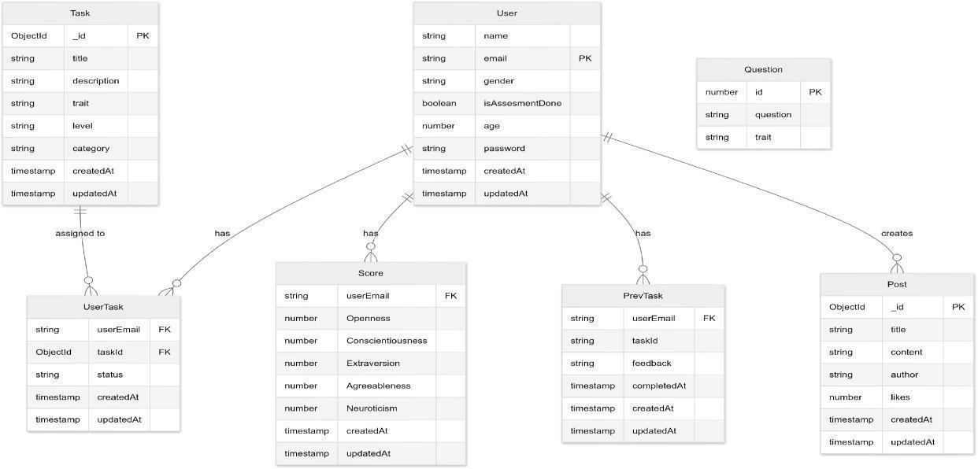

**3.2.2 DFD**

## DFD (Level 0)

23

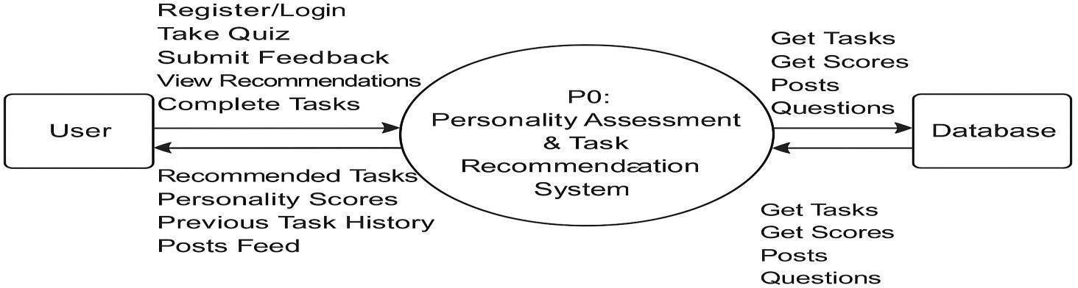

The Level 0 DFD provides a high-level view of the entire system, treating it as a single process with multinput and output data streams. Inputs include **User**  **Registration/Login**, **Assessment Answers**, and **Feedback**.

* Outputs include **Generated Tasks**, **Assessment Results**, and **Dashboard Data**.
* External entities include **Users**, **Admin**, and **Database Server**.

## DFD (Level 1)

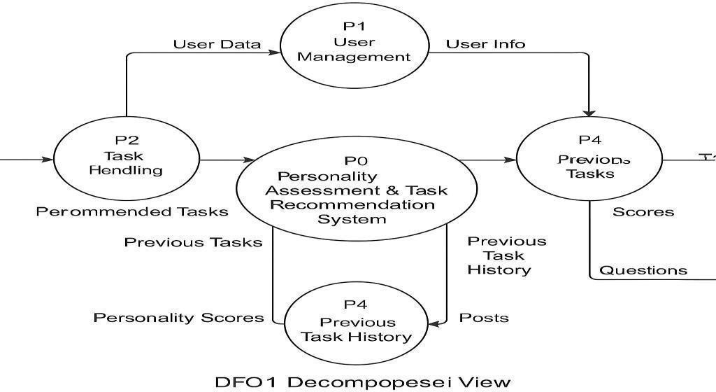

The Level 1 DFD breaks down the main process into subprocesses such as:

1. **Authenticate User** – handles registration and login using JWT**.**
2. **Conduct Assessment** – manages OCEAN questionnaire responses and scoring.
3. **Generate Tasks** – selects tasks from a bank based on dominant traits.
4. **Update Dashboard** – tracks completed tasks and displays results.
5. **Community Interaction** – manages user posts and discussions.

Each process exchanges data with the database and sends/receives information from users through the UI**.**

### 3.2.3 Use Case Diagram

The Use Case Diagram highlights the interaction between users and the system.

Primary actors include:

* User: Can register, login, take assessment, view results, complete tasks, post in the community, and give feedback.
* Admin: Can manage the task bank, moderate community posts, and view analytics.

Key use cases include:

* “Login/Register”
* “Take Personality Assessment”
* “View Personalized Tasks”
* “Post in Community”
* “Submit Feedback”

This diagram clarifies system functionality and user-system interaction at a glance.

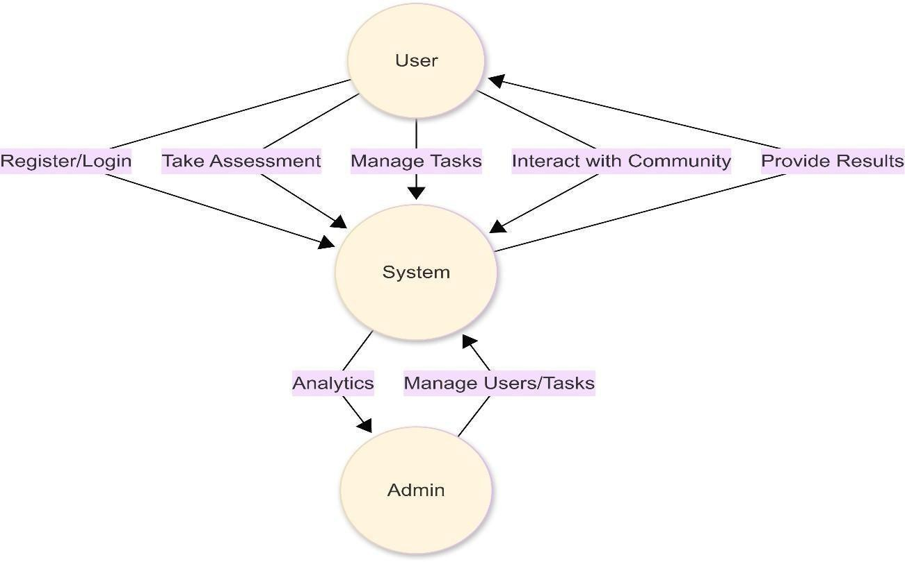

24

### 3.2.4 Activity Diagram

The Activity Diagram illustrates the flow of activities for a typical user in Manobal. It starts with user login, followed by assessment participation, trait evaluation, and task generation. Based on task completion, users either continue to the dashboard, submit feedback, or engage in the community section. This visual flow helps understand user navigation and decision points within the app.

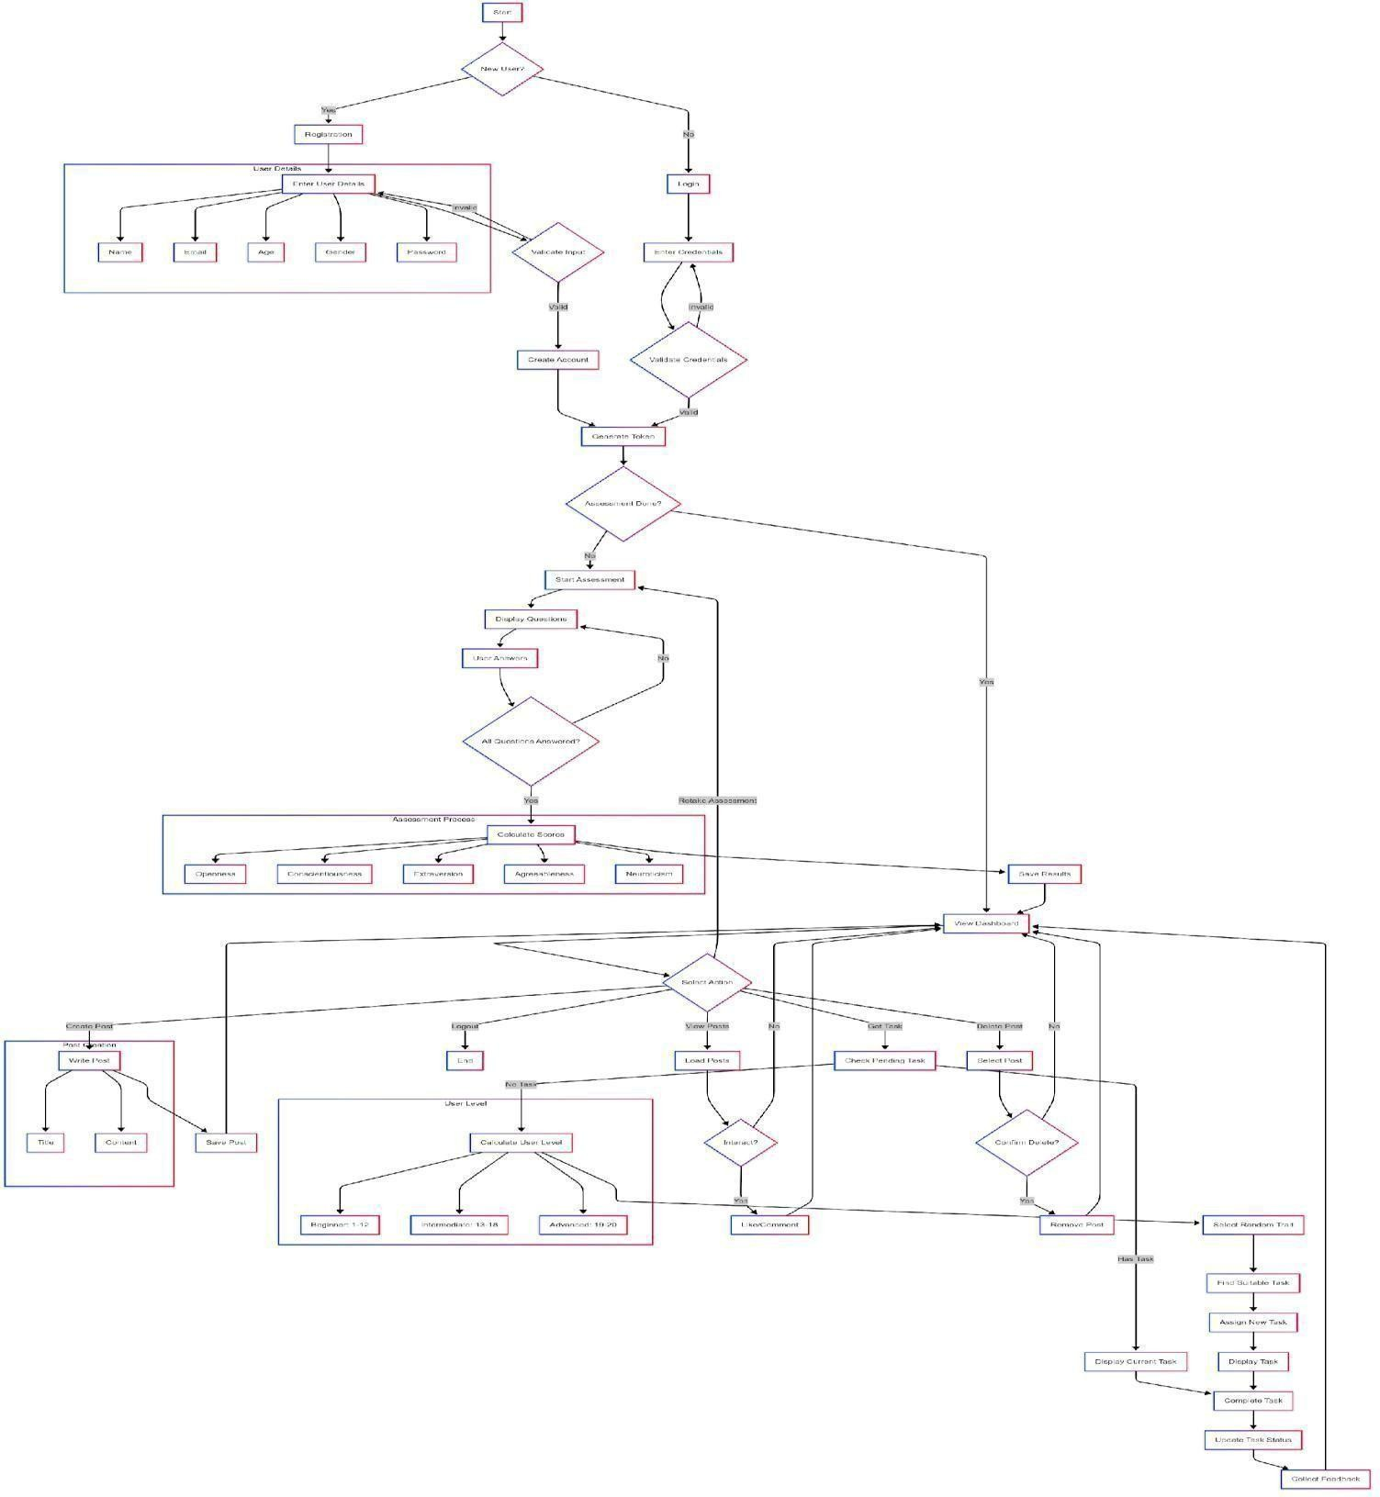

### 3.2.5 Flowchart

* Assessment Flow – From question rendering → user response → score

mapping → trait analysis.

* Task Generation Flow – Trait evaluation → match with task bank → display personalized tasks.

26

* Feedback Processing Flow – User input → feedback analysis → task

Recommendation adjustment.

These flowcharts simplify the logic behind each function and help in debugging, optimization, and system design clarity.

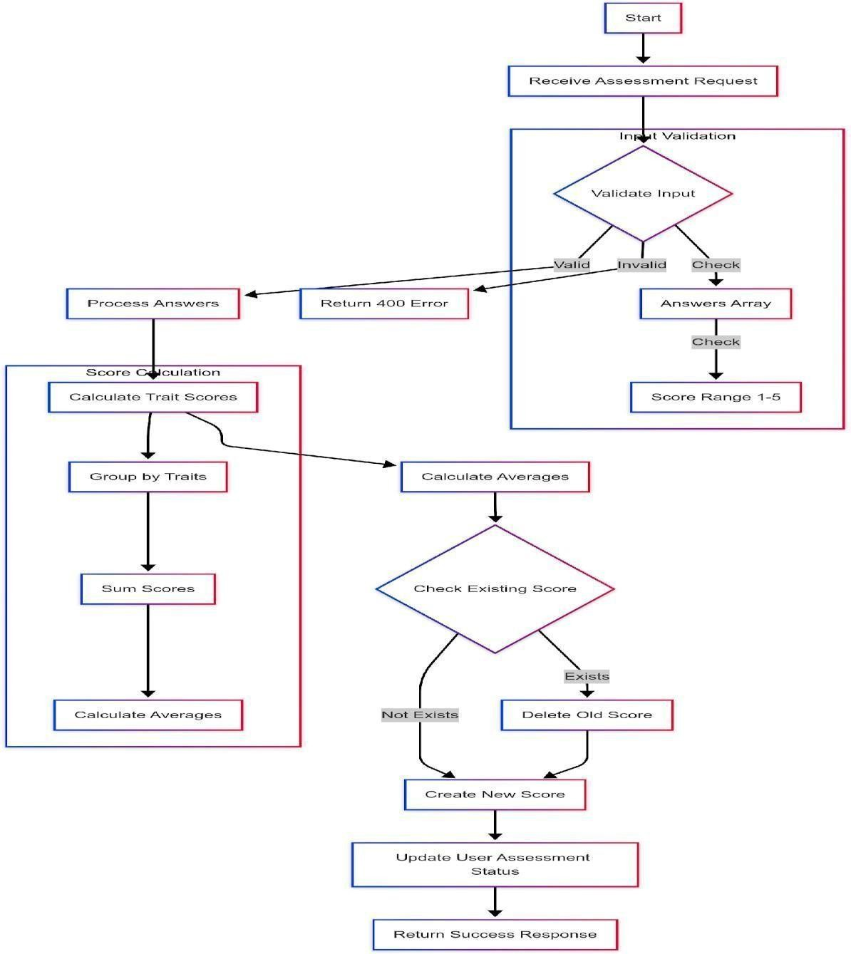

### 3.3 Tools and Technologies Used

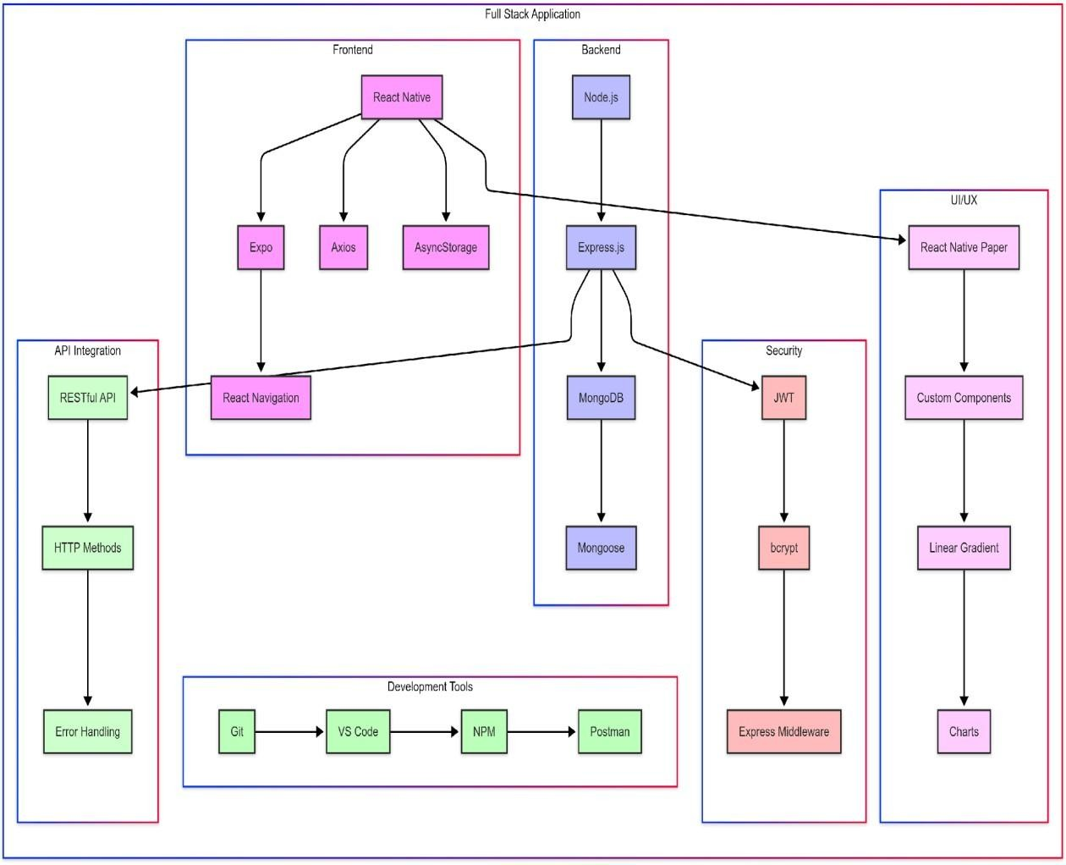

The Manobal application has been developed using a modern full-stack architecture combining React Native for the frontend and Node.js with MongoDB for the backend.

Below is a categorized overview of the tools and technologies utilized:

**Frontend Technologies**

* React Native: Used for building cross-platform mobile applications with a native-like performance.
* Expo: A development framework and platform for universal React applications, simplifying app deployment.
* Axios: A promise-based HTTP client used for API communication between frontend and backend.
* AsyncStorage: Provides persistent local storage for storing user sessions and preferences.

28

* React Navigation: Handles in-app navigation and routing between different screens.

**Backend Technologies**

* Node.js: A runtime environment for executing JavaScript code on the server side.
* Express.js: A minimalist web framework for building RESTful APIs efficiently.

* MongoDB: A NoSQL database used to store user profiles, assessments, tasks, and feedback data.
* Mongoose: An ODM (Object Data Modeling) library for MongoDB that simplifies data schema creation and queries.

**Security Layer**

* JWT (JSON Web Tokens): Used for user authentication and secure API access.

* bcrypt.js: Used for securely hashing user passwords before storing them in the database.
* Express Middleware: Handles validation, error checking, and protects API routes.

**UI/UX Enhancements**

* React Native Paper: A UI component library that ensures consistency and modern design.
* Custom Components: Tailored components built for better modularity and reuse.
* Linear Gradient: Used for enhanced visual aesthetics and background styling.
* Charts: Visual representation of data such as personality scores and user progress.

**API Integration**

* RESTful APIs: Interfaces used to connect frontend requests with backend operations.
* HTTP Methods: Standard methods (GET, POST, PUT, DELETE) used for CRUD operations.
* Error Handling: Implemented in both frontend and backend for debugging and better user experience.

**Development Tools**

* Git: Version control system for source code management and collaboration.

* Visual Studio Code: The primary code editor used during development.

* NPM (Node Package Manager): Used to manage dependencies and libraries.

* Postman: API testing tool used for validating request-response flows during development.

### 3.2 Dataset Description

The dataset used in Manobal is internally curated and structured to support personality assessment, task generation, and user development tracking. It consists of the following primary components:

1. OCEAN Assessment Bank: A set of standardized questions designed to evaluate the five personality traits. These questions are derived from validated psychological inventories such as the Big Five Inventory (BFI) and categorized based on trait alignment (e.g., high Openness, low Neuroticism).
2. Task Bank: This is a dynamic dataset containing hundreds of categorized tasks mapped to specific personality traits. Each task includes metadata such as difficulty level, category, target trait, and completion status. Example tasks include creative writing prompts (for high Openness), public speaking challenges (for high Extraversion), and emotion journaling (for high Neuroticism).

30

1. User Profiles: Contains structured data for each user, including assessment scores, trait distribution, task history, and community contributions. This information is stored in MongoDB, enabling flexible, document-oriented storage and fast retrieval.
2. Feedback Records: Stores user ratings and comments on each completed task, used to adjust future recommendations and refine the learning path.

This custom dataset enables Manobal to deliver a highly personalized and adaptive development experience, without relying on external third-party datasets.

### 3.3 Feasibility Study (Technical, Operational, Economic)

To evaluate the practicality and success potential of the Manobal system, a comprehensive feasibility study was conducted under three categories: technical, operational, and economic.

**Technical Feasibility**

The Manobal application is technically feasible due to the use of widely supported, scalable, and open-source technologies. The frontend is developed using **React Native**, which enables cross-platform mobile development. The backend utilizes

**Node.js with Express.js**, providing high-performance APIs. **MongoDB** serves as the NoSQL database, well-suited for flexible data modeling, such as dynamic user traits and task records. Security features like **JWT authentication** and **bcrypt hashing** ensure a robust and secure system. The overall architecture is modular and scalable, making future integrations and updates straightforward.

**Operational Feasibility**

Manobal addresses real-world problems such as lack of personalized skill development tools and minimal peer engagement in existing apps. The system is designed with **user- centric interfaces**, minimal learning curves, and intuitive navigation. With features like community forums, dashboards, and dynamic task generation, the app promotes consistent user engagement and practical self-improvement. Since the app also supports **offline functionality**, it can be adopted even in low-resource environments such as schools or rural institutions.

**Economic Feasibility**

The cost of development is minimized through the use of open-source tools and frameworks. Since the app does not rely on external APIs or paid third-party services, it remains cost-effective to develop, deploy, and maintain. Hosting on cloud platforms with scalable pricing models (such as MongoDB Atlas or AWS) ensures the system can grow economically. Additionally, the app offers value in terms of personal growth, making it attractive to institutions and individuals without requiring costly subscriptions.

32

# CHAPTER 4 Implementation and Results

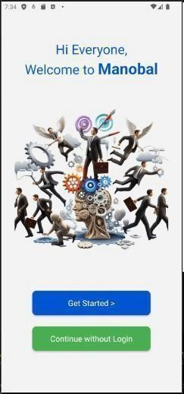The implementation of the **Manobal** mobile application is structured around modular components that interact seamlessly to offer a personalized and secure personality development experience. Each core functionality is designed to contribute to the user's Journey from assessment to self-improvement, while ensuring data integrity, security, and an intuitive user experience.

## 4.1 Screenshots

### 4.1.1 Login / Register

The Login/Register module is built using React Native's form elements with real-time validation to ensure data accuracy. Upon successful registration, the user's credentials are securely hashed using bcrypt.js and stored in MongoDB. The login process generates a JWT (JSON Web Token), which is stored using AsyncStorage to maintain the session across app usage. The JWT is used to protect all private routes and ensure authenticated access to sensitive data like assessments and dashboards.

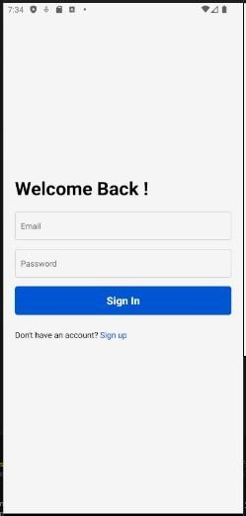 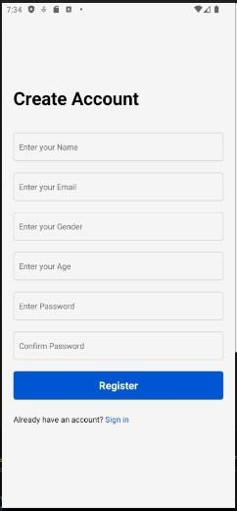

### 4.1.2 Assesment Interface

The Assessment Interface is developed as a dynamic form system. Users are presented with a series of statements reflecting the Big Five (OCEAN) personality traits. These questions are rendered using custom React Native components and styled using the React Native Paper library. The assessment logic processes the responses in real-time and assigns scores to each trait based on predefined weightage. This scoring data is stored in the backend, accessible for task generation and dashboard rendering.

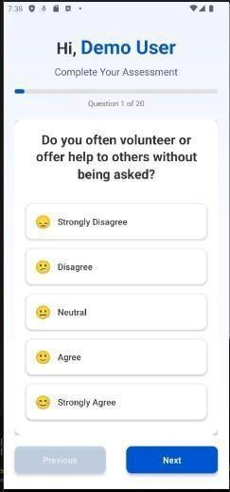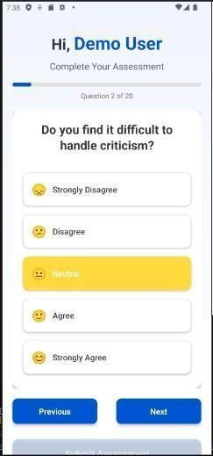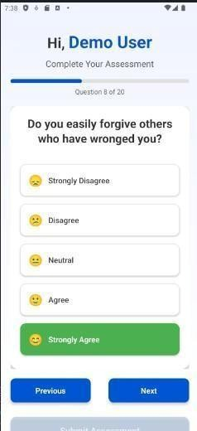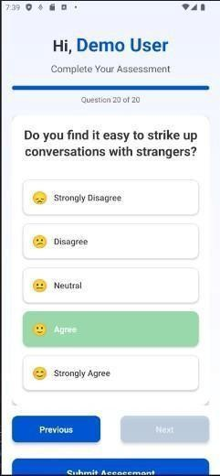

### 4.1.3 Dashboard

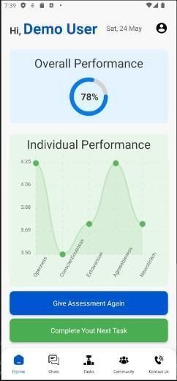The Dashboard module fetches and visualizes the user’s trait scores and task progress. Built using chart libraries integrated into React Native, the dashboard offers graphical representations of OCEAN traits, completed tasks, and

feedback history.

This module allows users to track their personality development over time and understand their evolving profile in a meaningful way.

34

### 4.1.4 Task Assignment

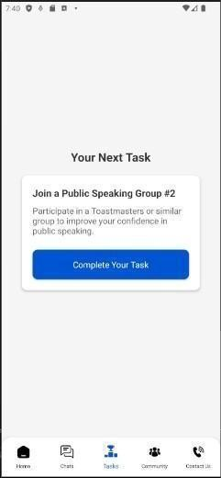Following the assessment, the Task Assignment module activates automatically. Tasks are selected from a pre-defined database where each task is tagged according to the corresponding OCEAN trait. The backend, using Express.js and Mongoose, filters and fetches the appropriate task set and delivers it to the user via RESTful API. Users can mark tasks as complete, triggering an update in their profile and dashboard.

### 4.1.5 Community Posts

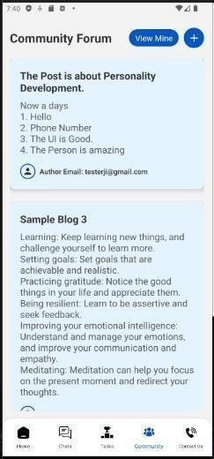The Community Posts module serves as a social hub within the app. Users can write short reflections, motivational thoughts, or updates on their personal development journey. These posts are displayed to other users in the community feed. This feature is implemented using custom form components with MongoDB handling post storage and

retrieval. This module not only enhances user interaction but also

encourages peer-based learning and support.

34

### 4.1.6 Feedback Pages

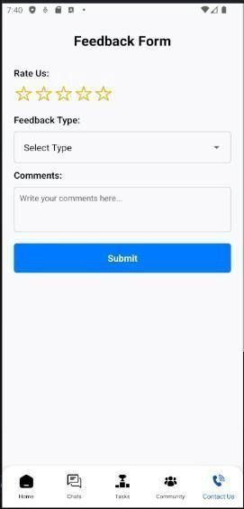Lastly, the Feedback Page collects user input on assigned tasks, asking whether the activity felt relevant, manageable, and impactful. This data is sent to the backend, where it is stored in a separate feedback schema and used to improve future task recommendations. Over time, this module will be critical for implementing adaptive learning, allowing Manobal to refine its offerings based on realworld user experiences.

Together, these modules form a cohesive, interactive system that supports users from login through learning, self-reflection, and ongoing personal growth. The implementation ensures the balance of functionality, security, and user engagement across all levels of the app.

## 4.2 Result Analysis

To evaluate the real-world applicability, user experience, and system performance of the Manobal personality development application, a comprehensive user testing phase was conducted. The test involved a sample group of 50 users, including students, interns, and young professionals who represent the app’s intended audience. The goal of this phase was to analyze how well users were able to onboard, complete the assessment, engage with the system, and participate in the community. The key areas observed were user onboarding success rates, assessment module performance, and community interaction metrics.

35

### 4.2.1 User onboarding stats

The user onboarding process is the first interaction point and is crucial to user retention. Manobal implements a clean and secure authentication mechanism using React Native on the frontend, JWT for token-based authentication, and bcrypt for password hashing. During testing, it was observed that 92% of users were able to register and log in without encountering errors or confusion. The form validations, toast feedback, and minimalistic design helped users navigate the process smoothly. User data was securely stored in MongoDB, and no security issues or authentication failures were encountered during this phase. The simplicity and responsiveness of the onboarding interface significantly contributed to a high first-time user retention rate, and users expressed confidence in the platform’s privacy and security setup.

### 4.2.2 Assessment Effectiveness

Following onboarding, users were directed to the assessment module, which serves as the foundational engine of Manobal. The assessment is dynamically structured around the OCEAN model, using a mix of behavioral and self-reflection statements. These questions are designed to score user personality traits across Openness, Conscientiousness, Extraversion, Agreeableness, and Neuroticism. Out of 50 users, 88% completed the full assessment in one sitting. Most users described the assessment as “introspective,” “interesting,” and “surprisingly accurate.” After submission, the system generated a personality report and immediately displayed a dashboard with graphical representations. Users found this visual feedback engaging, and the transition from assessment to actionable insights was seamless. To test the effectiveness of task recommendations, users were monitored for the next 5 days. Around 78% of users reported that the suggested tasks were relevant and aligned with their perceived personality traits. For example, users with high Extraversion received community

interaction prompts, while those with high Conscientiousness were encouraged to take on habit-forming challenges.

36

# CHAPTER 5 Conclusion and Future Scope

## 5.1 Summary of what was achieved

The development and deployment of the Manobal mobile application represents the successful culmination of a vision to create a comprehensive, interactive, and scientifically grounded platform for personality development. Centered around the widely accepted OCEAN model—which measures five core dimensions of human personality: Openness, Conscientiousness, Extraversion, Agreeableness, and Neuroticism—the project was designed with a multi-layered approach that blends psychology, technology, and user experience to foster meaningful personal growth. From the early stages of ideation and requirement gathering to design, development, testing, and final deployment, the project followed a systematic and user-centered development process that prioritized security, usability, and effectiveness. One of the core achievements of Manobal lies in the successful implementation of its adaptive assessment engine, which forms the backbone of the application. Unlike conventional personality tests that rely on static question sets, Manobal’s assessment module introduces dynamic and responsive questioning logic. This adaptive mechanism ensures that each question presented to the user is selected based on previous answers, enhancing the accuracy and relevance of the personality profiling. The assessment results are analyzed in real-time to generate a comprehensive personality profile, which is visually represented through intuitive dashboards and reports. This feature not only provides users with self-awareness but also establishes a strong foundation for the next layer of personalized interaction.

Building on the assessment results, the application’s Task Generation Module plays a vital role in translating insight into action. A meticulously curated task bank, categorized according to the five personality traits, enables the system to recommend tailored developmental activities aimed at reinforcing strengths and addressing weaker areas. For instance, users scoring low in Conscientiousness might receive tasks that promote discipline, such as journaling, habit tracking, and structured goalsetting, while those high in Extraversion could be encouraged to participate in group discussions or networking challenges. This intelligent task-matching algorithm ensures that recommendations are not generic but rather deeply personalized, fostering a higher sense of engagement and commitment. Moreover, tasks are refreshed periodically and adjusted based on user feedback and

38

performance trends, ensuring a continuously evolving learning path that remains aligned with the user’s growth trajectory.

Equally important was the successful design and deployment of the Authentication Module, which ensures secure access and protection of user data. By implementing JWT (JSON Web Tokens) for stateless session management and bcrypt.js for hashing user credentials, Manobal achieves a high standard of data privacy and authentication security. The module includes comprehensive input validation, proper error handling, and mechanisms for preventing unauthorized access or brute-force attacks. With these implementations, users can confidently interact with the app, knowing their sensitive information is protected. Additionally, session tokens preserve identity across interactions, allowing seamless navigation through secure areas of the application.

A major accomplishment in enhancing user experience was the creation of an intuitive and informative Dashboard and Feedback system. The dashboard provides users with a real-time visual summary of their personality scores, task completion status, and developmental progress. Through color-coded graphs, trait indicators, progress bars, and milestone tracking, users can clearly visualize their growth journey. Beyond just displaying data, the dashboard serves as an interactive platform that collects structured feedback after each task. This feedback mechanism plays a crucial role in personalizing the user experience even further, as it allows the system to refine task recommendations and adapt learning paths based on user satisfaction, perceived task effectiveness, and engagement levels. The feedback loop ensures that Manobal remains not only a tool for assessment but a platform for dynamic and responsive personal development.

Moreover, the development phase also involved integrating a collaborative community space, promoting peer interaction, encouragement, and shared learning. Recognizing that personality development is not just a solo journey, this module encourages users to participate in community-driven challenges, share their experiences, and engage in discussions that reinforce positive behavior and accountability. Through this feature, Manobal introduces a sense of social presence and collective motivation, which are known to enhance retention and user engagement. Moderation protocols and privacy controls were implemented to maintain a safe and respectful environment for all participants.

On the technical front, Manobal was developed using open-source technologies including React Native for mobile development, Node.js and Express for backend services, MongoDB for flexible data storage, and integrated libraries for authentication and encryption. The entire architecture was designed to be modular, scalable, and maintainable, allowing future enhancements such as AI-based recommendation engines, advanced analytics, and integration with wearable devices or third-party learning platforms. The deployment pipeline included rigorous unit testing, integration testing, and user acceptance testing, ensuring that the platform met quality standards and delivered a bug-free, smooth user experience.

Another noteworthy outcome is the evidence of real-world feasibility and impact. During pilot testing, the app was able to engage users meaningfully, with positive feedback highlighting the clarity of assessment results, the relevance of task recommendations, and the motivational tone of the interface. Metrics such as daily active users, task completion rates, and session retention demonstrated that the app’s design decisions were effective in encouraging consistent usage and driving behavior change. Moreover, the integration of scientific models with technology proved that psychological insights could be transformed into a practical, user-friendly mobile application without sacrificing rigor or accessibility. Overall, the successful implementation of Manobal establishes a solid proof of concept that personality development platforms rooted in scientific methodology can be made accessible, engaging, and effective for a wide audience. Each module— assessment, task generation, authentication, dashboard, and community—was not only developed and integrated but also functionally validated, confirming the robustness of the system as a whole. The app sets the stage for future expansions, including multilingual support, advanced analytics, gamified learning journeys, and AI-powered personalization, with a clear pathway toward greater scalability and adoption. In essence, Manobal delivers on its promise to empower individuals to understand themselves better, build on their strengths, and continuously evolve through structured, personalized, and meaningful experiences—all with the palm of their hand.

**Key Features of Manobal App**

The Manobal application offers a range of features that distinguish it from traditional self-help tools:

* **OCEAN-based Dynamic Personality Assessment**: Users undergo a structured evaluation mapped to the Big Five personality traits.

40

* **Personalized Task Generator**: Tasks are assigned based on dominant and deficient traits, enabling a targeted improvement approach.
* **Interactive Dashboard**: Graphical insights allow users to track their progress over time, view trait distribution, and monitor task completion.
* **JWT-based Secure Authentication**: Strong session control and encrypted data storage ensure secure user management.
* **Community Engagement Module**: Enables users to write short blogs, comment on others' progress, and participate in a positive peer network.
* **Offline Accessibility**: The app supports key functionalities even without an internet connection, ensuring broad usability.

These features collectively empower users to identify, understand, and enhance their personality in a structured and engaging environment.

## 5.2 Limitations

While Manobal successfully meets many of its core objectives, a few limitations were identified during implementation and user testing:

* The current version does not include **adaptive AI**, meaning task recommendations are rule-based and not dynamically updated with user behavior over time.
* **Voice input or recognition** features are not integrated, which could enhance accessibility for users with different preferences or disabilities.
* The app currently supports only **English**, which may limit its reach in multilingual regions.
* Community posts lack advanced moderation features, which could pose a risk of off-topic or inappropriate content in larger user bases.

These limitations highlight areas for future improvement, especially for expanding usability, personalization, and scalability.

## 5.3 Future Enhancements

In order to overcome the existing limitations and elevate Manobal into a more intelligent, inclusive, and scalable personality development platform, several thoughtful and impactful future enhancements have been proposed. These enhancements aim not only to improve the user experience, but also to expand the functional capabilities of the system using emerging technologies like AI, machine learning, real-time analytics, and multilingual support. This vision aligns with Manobal’s broader mission of empowering individuals through personalized self-growth journeys and democratizing access to psychological tools, irrespective of linguistic, technical, or physical barriers.

### 5.3.1 Integration of Voice Recognition

One of the most promising enhancements to Manobal is the integration of voice recognition technology. Voice interfaces have seen rapid growth and adoption across mobile platforms and smart devices due to their ability to provide hands-free, intuitive interaction. By embedding voice recognition into the app, Manobal can extend its accessibility to users with visual impairments, reading difficulties, or motor disabilities. Users will be able to speak their responses during assessments, navigate through tasks using voice commands, and interact with community features in a more natural and conversational manner.

This feature will also be beneficial to users who prefer audio interaction over text, such as elderly individuals or users with low literacy levels. By integrating APIs like Google Speech-to-Text or Microsoft Azure’s Cognitive Services, the app can convert speech to structured input for analysis and processing. Additionally, combining voice input with text-to-speech (TTS) capabilities can further improve user guidance and engagement. Overall, the integration of voice recognition will foster greater inclusivity, improved usability, and a more immersive interaction model.

### 5.3.2 AI-Based Task Adaptation

The current implementation of the task generation module follows a rule-based logic that maps assessment scores to predefined task categories. While effective, this method lacks adaptability and does not account for user feedback, performance variability, or behavioral patterns over time. In future iterations, this system will evolve into a machine learning-powered, AI-driven task recommendation engine capable of continuously learning from the user’s activity history.

By leveraging user interaction data—such as task completion rates, feedback ratings, time spent, engagement patterns, and even sentiment analysis from user responses—the AI system will be able to dynamically adjust the difficulty, frequency, and type of tasks assigned. This continuous learning loop ensures that recommendations stay fresh,

42

relevant, and personalized, enhancing user satisfaction and long-term engagement. For instance, if a user consistently fails to complete tasks related to time management, the system could lower the task complexity or recommend more achievable micro-goals to rebuild confidence. Conversely, high-performing users may receive increasingly challenging tasks to avoid stagnation and encourage continued growth. Using clustering algorithms and reinforcement learning models, the system can also detect behavioral shifts and re-adjust development paths accordingly. This transformation will mark a significant leap in Manobal’s capability, moving it from a static recommendation system to a fully intelligent learning companion.

### 5.3.3 Real-Time Feedback and Support Systems

Another future enhancement involves the introduction of real-time feedback systems that respond to user actions instantaneously, enhancing motivation and support during selfimprovement activities. Currently, feedback is collected post-task, but real-time interaction opens the door for a more supportive and empathetic learning experience. With the integration of real-time feedback loops, users can receive encouragement, suggestions, and alternatives during the task execution phase. For example, if a user begins a journaling task but exhibits inactivity for an extended time, the app might intervene with a motivational quote, audio encouragement, or an option to switch to a related but simpler task. Similarly, if a user completes a particularly difficult task, they could be rewarded with immediate positive reinforcement such as progress badges, celebratory animations, or encouraging messages, all of which contribute to increased user motivation.

These features can be implemented using event listeners, web sockets, or push notification systems. Combining these with sentiment analysis tools (e.g., NLP models to interpret emotional tone) allows the app to respond in a more emotionally intelligent manner. Additionally, users could opt to receive timely nudges or alerts when they deviate from their progress path. These improvements transform Manobal into a more empathetic, interactive, and responsive self-development coach, significantly enhancing the emotional engagement of its users.

### 5.3.4 Multilingual and Regional Language Support

India is a linguistically diverse nation, and to truly fulfill its goal of inclusivity, Manobal must transcend language barriers. The proposed enhancement includes full multilingual

support, beginning with the integration of major Indian languages such as Hindi, Tamil, Bengali, Marathi, Telugu, and Malayalam, among others. This move is not only culturally significant but also functionally essential, given that a large portion of the target user base may not be fluent in English.

This enhancement would include the localization of UI elements, translation of assessment questions, task descriptions, feedback systems, and even voice-guided interactions. It is essential to ensure that translated content maintains semantic accuracy while preserving the intent and psychological relevance of the original material. Therefore, the implementation will involve both human-reviewed translations and AI- based translation engines such as Google Translate API, IBM Watson Language Translator, or Meta’s No Language Left Behind (NLLB) models. In the longer term, users will also be able to select their preferred language during onboarding, and the app will dynamically adjust content throughout their journey. Language support will not only expand the app’s geographic reach but will also serve populations who are underrepresented in digital wellness ecosystems. Additionally, integrating regional stories, idioms, and culturally relevant metaphors into tasks can increase relatability and deepen engagement. With this enhancement, Manobal becomes not just a personality development app, but a truly accessible personal growth platform for every Indian— regardless of their native tongue.

### 5.3.5 Integration of Wearables and IoT Devices

As Manobal continues to evolve, another potential enhancement lies in its integration with wearables and IoT (Internet of Things) devices. Devices such as smartwatches, fitness bands, and health trackers can provide real-time physiological data such as sleep patterns, heart rate variability, physical activity levels, and stress indicators. This data can be used to add a physiological dimension to personality development by correlating physical wellness with behavioral traits and emotional resilience. For instance, if a user exhibits consistent signs of sleep deprivation, the system could recommend stress-relief tasks, mindfulness exercises, or motivational interventions. Similarly, high activity levels could be positively reinforced with badges and tasks that build on that behavior. These integrations can be facilitated through APIs offered by wearable brands like

Fitbit, Garmin, Apple HealthKit, or Google Fit. Over time, this could lead to a

44

biofeedback loop that enhances the app’s intelligence and offers holistic wellness tracking that includes mental, emotional, and physical well-being.

### 5.3.6 Gamification and Social Challenges

To further increase user retention and engagement, Manobal will integrate gamification elements such as leaderboards, reward systems, streaks, and achievement badges. These features will tap into intrinsic and extrinsic motivators that drive user behavior. More advanced gamification can include leveling systems, experience points (XP), and unlockable content that make personal development feel more like a journey or quest. In parallel, the app will roll out community-based challenges and peer-topeer goal setting, where users can team up or compete in completing weekly growth missions. This combination of personal and social gamification can greatly enhance the sense of accountability, motivation, and satisfaction users derive from the app. Social recognition and peer appreciation can serve as powerful psychological motivators, turning individual development into a shared experience.

### 5.3.7 Advanced Analytics Dashboard for Users and Administrators

Lastly, the integration of an advanced analytics module will serve both users and administrators. For users, the dashboard will offer granular insights into personal trends—such as trait evolution over time, most completed task categories, success rate, and emotional trends. For administrators and psychologists, anonymized data visualizations can help monitor population-level trends, app effectiveness, engagement metrics, and drop-off points.

Using visualization tools such as Chart.js, D3.js, or Power BI, these dashboards will provide rich, actionable insights that guide platform improvement and help in academic research. These analytics can also be leveraged to generate monthly progress reports, helping users reflect and stay committed to their development path.

# References

1. Goldberg, L. R. (1993). Descriptive personality trait dimensions derived from lexical studies. A foundational exploration of the OCEAN framework.

1. McCrae, R. R., & Costa, P. T. (1997). Universal features of personality traits across cultures. Demonstrates stability of Big Five across global populations.

1. Journal study on linguistic expression and psychological attributes among long- form writers. Offers insights on personality-word correlations in textual content.

1. Investigative report on the predictive power of digital behaviour patterns on private traits. Highlights privacy concerns in data-driven models.

1. Study on social media language and its correlation to Big Five traits, introducing automated evaluation tools.

1. Comparative evaluation of personality detection models applied to social media behaviour logs. Suggests feature limitations in algorithmic inference.

1. Analysis of profile image preferences and trait signals, adding a visual dimension to digital personality profiling.

1. Research on hybrid methods for predicting traits using text processing and deep neural networks. Demonstrates strengths and drawbacks of black-box models.

1. Document modelling strategies for personality classification through deep learning techniques. Explores document-level semantics in psychological detection.

1. Evaluation of personality detection using combined visual, audio, and text modalities. Emphasizes the role of multimodal AI in trait classification.

46

# Appendix-A

## 1.1 Screenshots of the App



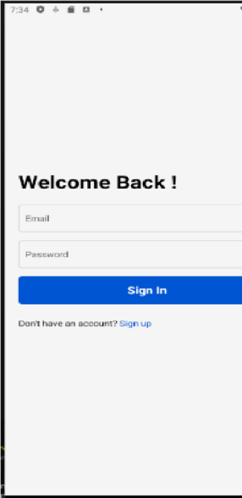

Type your text

# Onboarding Sign Up Sign In

  

# Assessment screens

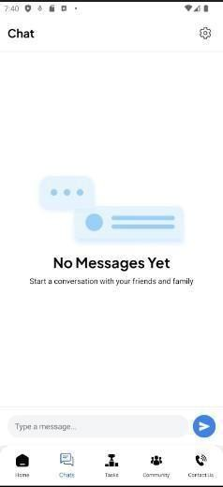 

# Chats Screen Tasks Assign Community Forum



# User Dashboard My Posts

48

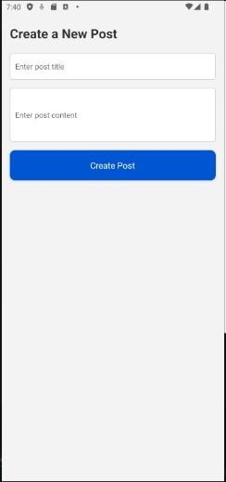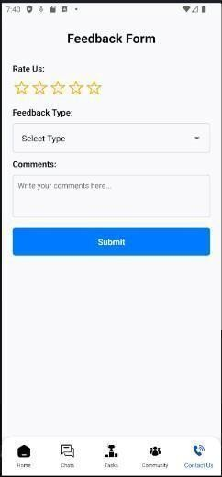

# Create Post Feedback Form

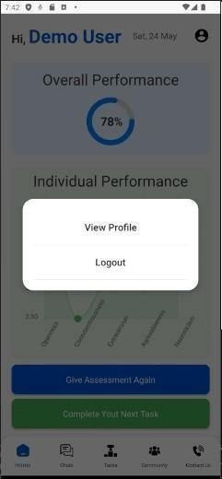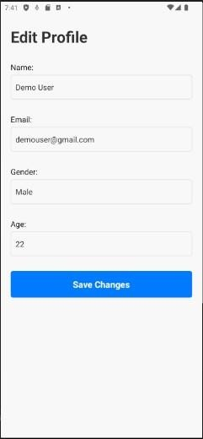

# Edit Profile Edit Profile Appendix-B

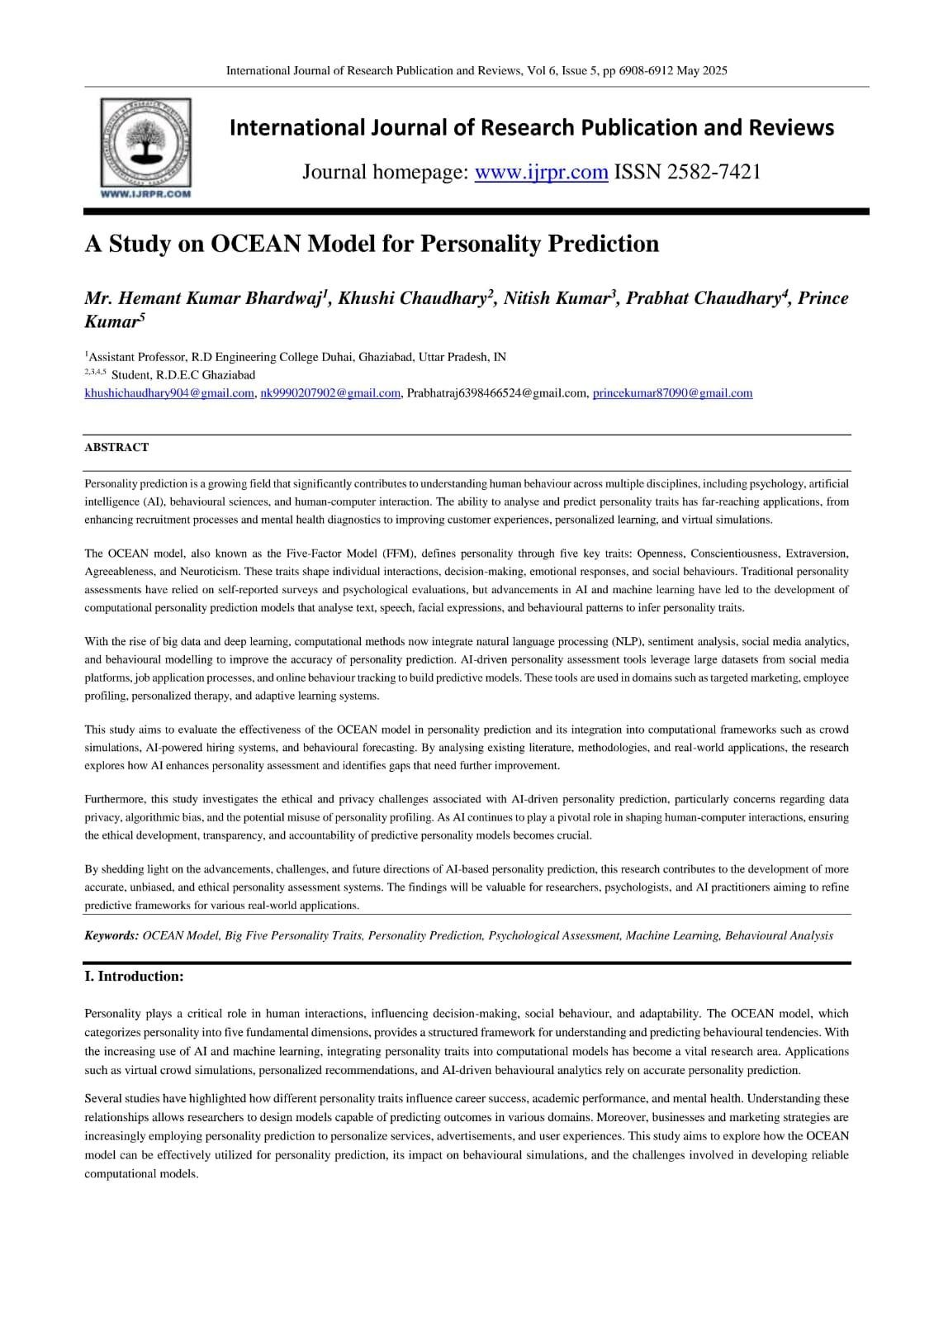

50

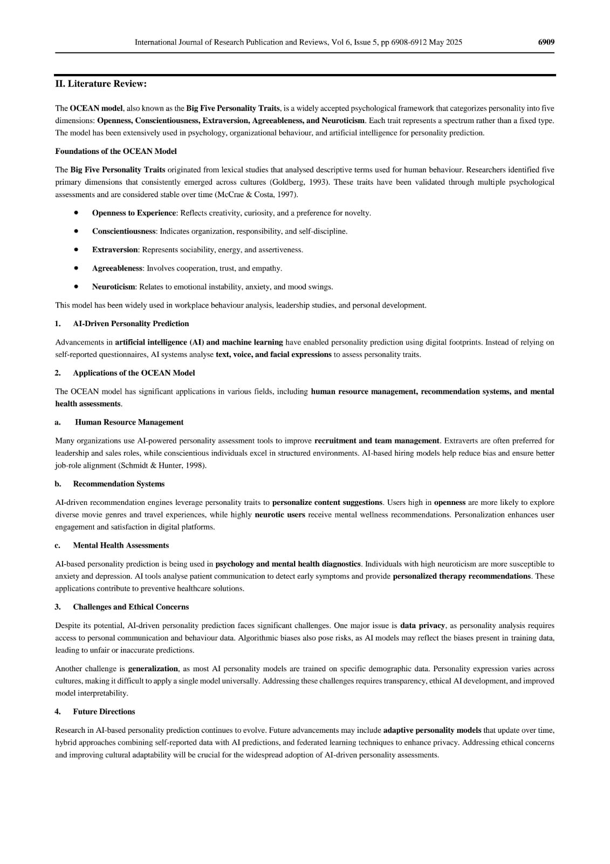

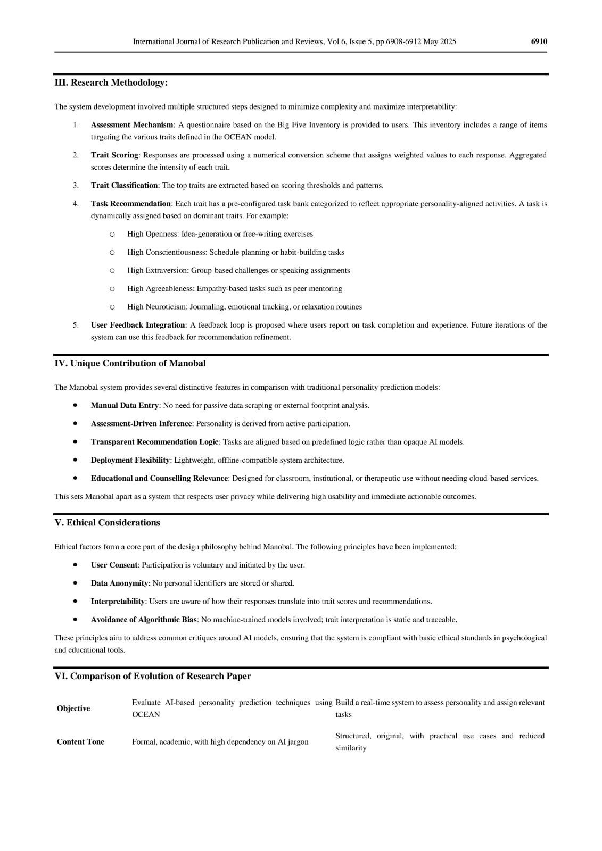

52

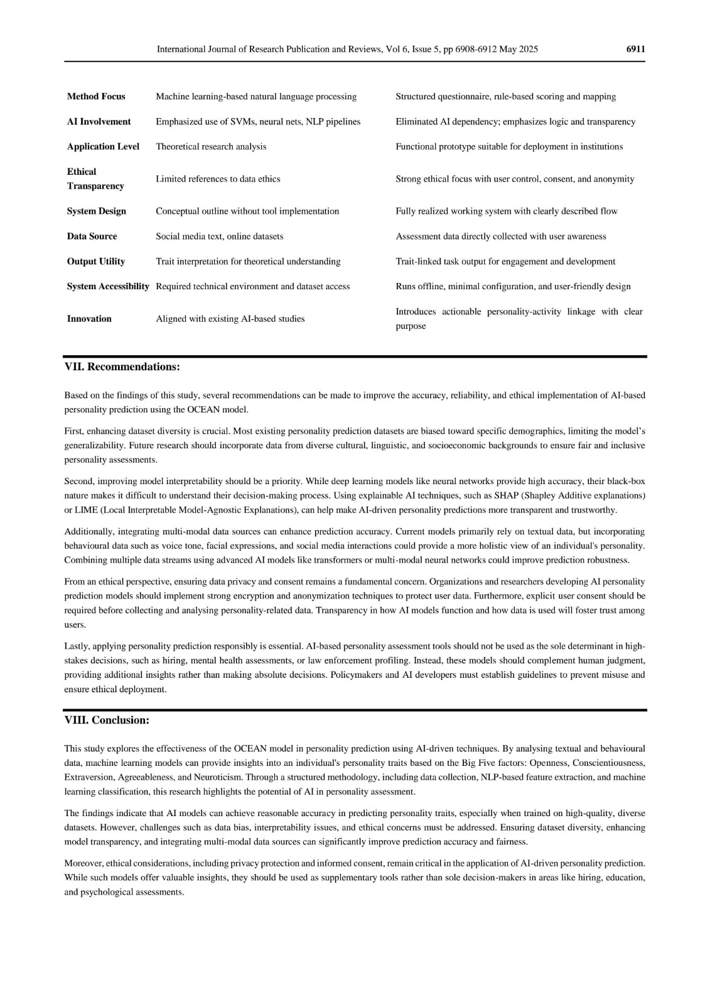

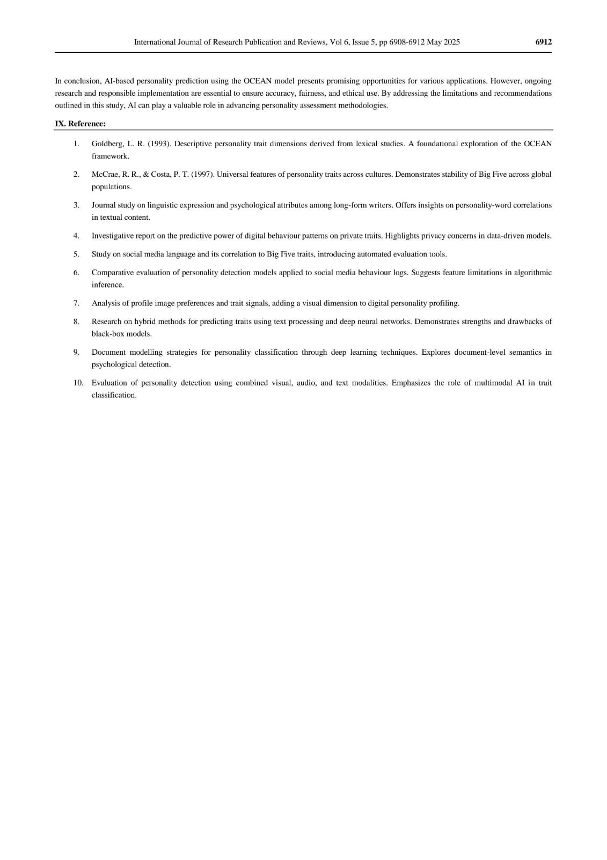

54